Muhammad Umar Farooq
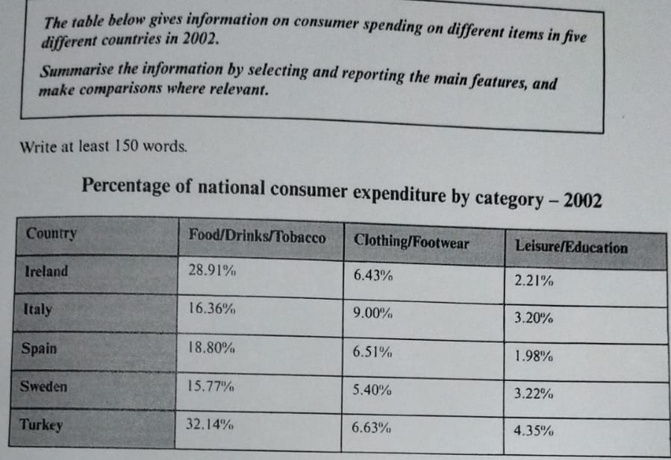
The provided table illustrates about domestic and national users’ expenditure on a range of commodities in five distinct states by the 2002.
Overall, food, drinks, and tobacco contributed the primarily, clothing covered an accountable segment of money and ranked on next, and educational expanses have a minimal allocation of expenditure according to the statistical information.
A comprehensive analysis revels that, Turkish people allot their 32.14% money to deal with food and related dues meanwhile, Ireland competed with 28.91% furthermore, Italy, Spain, and Sweden have probably shared the same trends on-an-average about 15%. Also detailed observation indicates that, clothing has a fundamental existence in their money distribution, Italian spent 9% to maintain attire and showed interest in personality grooming nonetheless, Ireland, Spain, and Turkey served almost 6% of wealth on footwears. As far as education came on the last, all five countries had invested a tiny portion of money which is between 1% to 5% over the time period.

